Dear {Insert Recipient’s name}

On Sunday, September 24, I will be participating in RBC Race for the Kids in support of the mental health care and research taking place at our local children’s hospital. The success of this event, and the funds raised to support the children and youth at CHEO, rely on energetic and engaged people like you!

I am hoping you will join me and become a part of {insert team name}.

RBC Race for the Kids offers a wide range of options. Timed all-terrain 5K and 10K routes and a fully accessible 2K Family Fun Run routes take participants of all ages and abilities through the beautiful grounds of Wesley Clover Parks. As a registered participant you will be issued your own numbered bib which is also your ticket to enjoy complimentary food and beverages, children’s activities and entertainment for all ages.

Here is why I am asking you to join our team and help raise funds:

CHEO is one of the largest providers of mental health services in Ontario and is home to one of the busiest pediatric Emergency Departments in Canada. CHEO has seen a drastic surge in children and youth arriving in the Emergency Department struggling with their mental health and thinking of suicide and self-harm. Because challenges affect their school, home and personal lives as well as the development of life skills, it is crucial to address mental health issues as soon as possible to avoid lifelong consequences. The RBC Race for the Kids has already made a real difference by raising funds for programs such as 1Call1Click – a service that connects kids with the right care at the right time. There is still a lot of work to do, and I hope you will help.

With your participation and fundraising we can ensure CHEO is equipped to provide world-class care for our region’s children and youth.
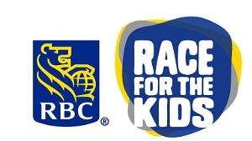
Click the link here to meet the team and become a member!
{insert link to team fundraising page}

Together, we are helping children and youth live their best lives.

Sincerely,
{INSERT YOUR NAME}

